
DATA MINING LAB TERMINAL PROJECT
JAWAD AHMAD (SP23-BDS-022)
ROHAN YOUNAS (SP23-BDS-035)


submitted to: Dr. mariam akbar

Smart Retail Analytics – Data Mining Project Report

1. Introduction
This project uses the UCI Online Retail dataset to derive meaningful customer insights through data mining techniques. We segment customers using clustering algorithms, discovering item associations with rule mining, and building classification models to identify high-value customers.

2. Data Preprocessing
- Removed rows with missing CustomerID.
- Filtered out canceled transactions (InvoiceNo starting with ‘C’).
- Ensured positive values for Quantity and UnitPrice.
- Transformed InvoiceDate to datetime.
- Created RFM features: Recency, Frequency, and Monetary.
- One-hot encoded top 10 countries for enriched feature modeling.

3. Distance Matrices and Similarity Measures
Euclidean Distance Matrix
- Based on RFM features, the Euclidean distance matrix was computed for a sample of 100 customers.
- Heatmap visualized the distances among customer pairs.
- Statistics:
  - Min Distance: 0.02
  - Max Distance: 5.83
  - Mean Distance: 1.42
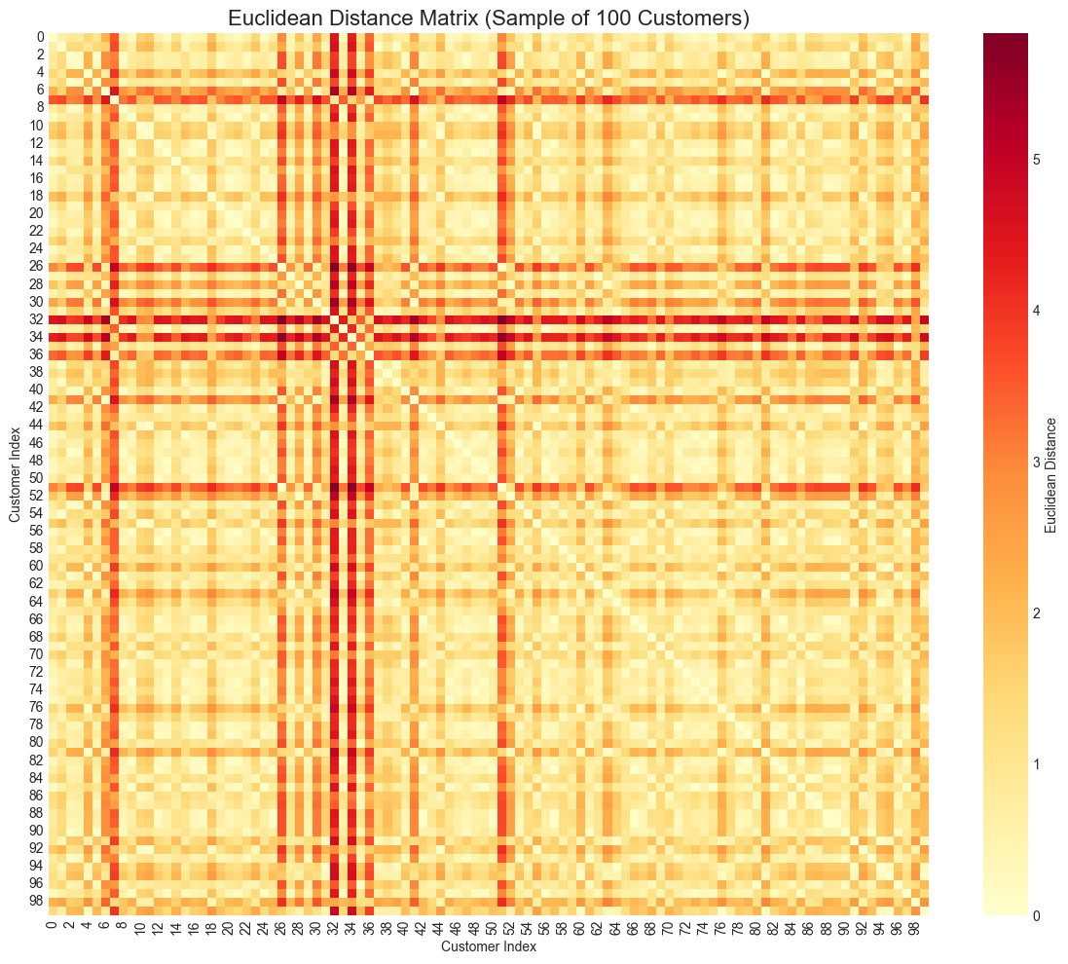
Jaccard Similarity Matrix
- The top 10 purchased items per customer were transformed into sets.
- Pairwise Jaccard similarity was computed for customer pairs.
- Result: Sparse similarity matrix showing overlap in item preferences among users.
- Statistics:
  - Max similarity (excluding diagonal): 0.429
  - Mean similarity (excluding diagonal): 0.006
  - Percentage of zero similarities: 89.7%
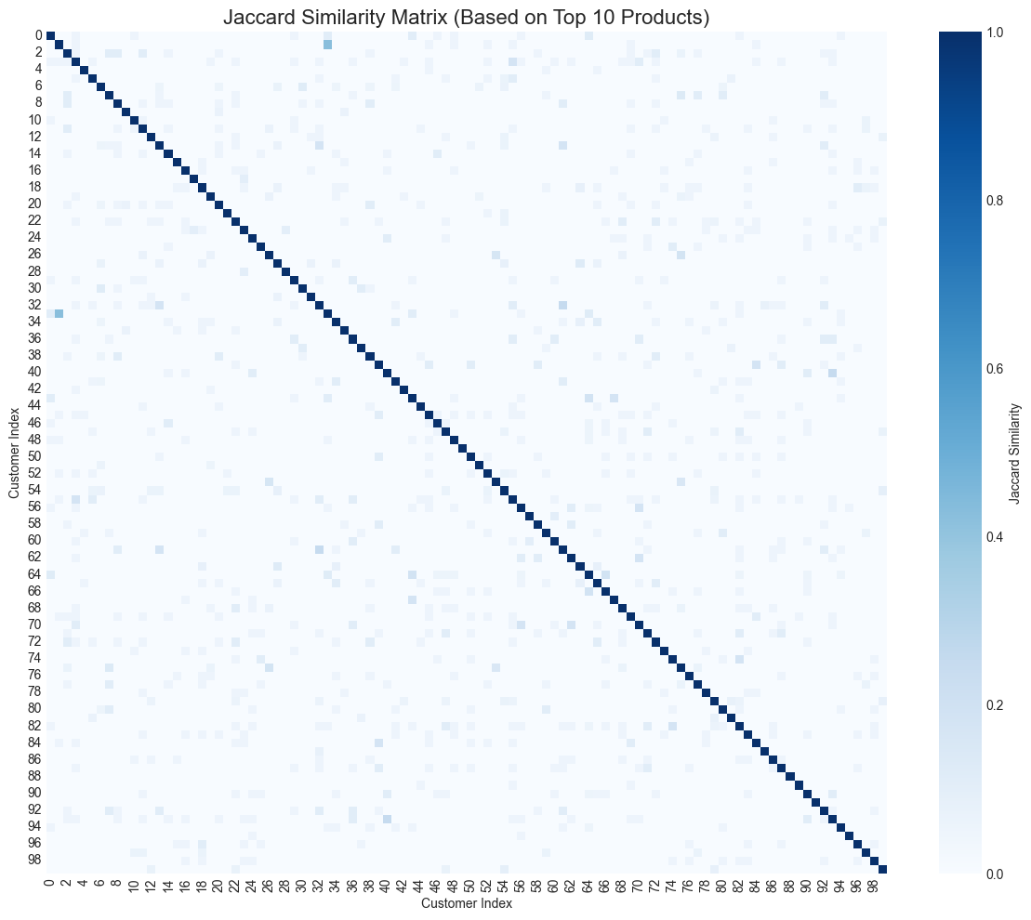

4. Clustering Analysis
Elbow Method & Silhouette Score
- Used the Elbow Method to find the optimal number of clusters (K).
- Optimal K = 2, confirmed using the Silhouette Score, which peaked near K=2.
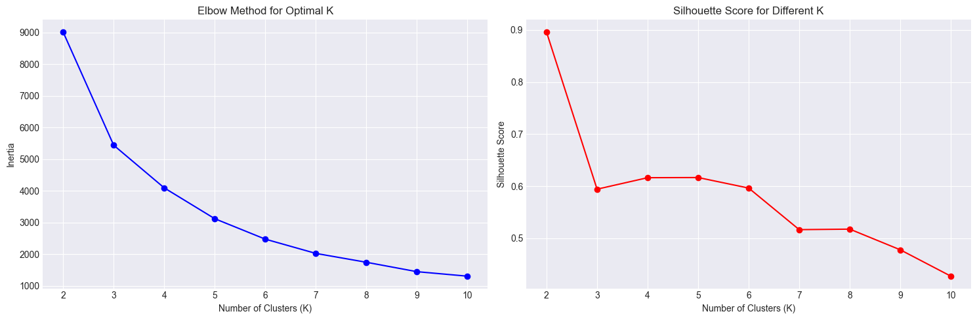
K-Means Clustering (K=2)
- For visualization clarity, a K=2 model was also built and reduced to 2D via PCA.
- Customers were visualized on PCA axes with color-coded cluster labels.
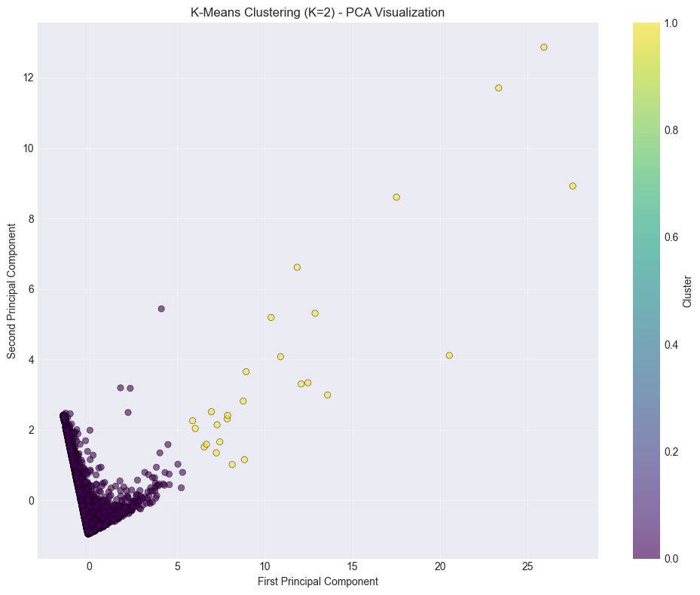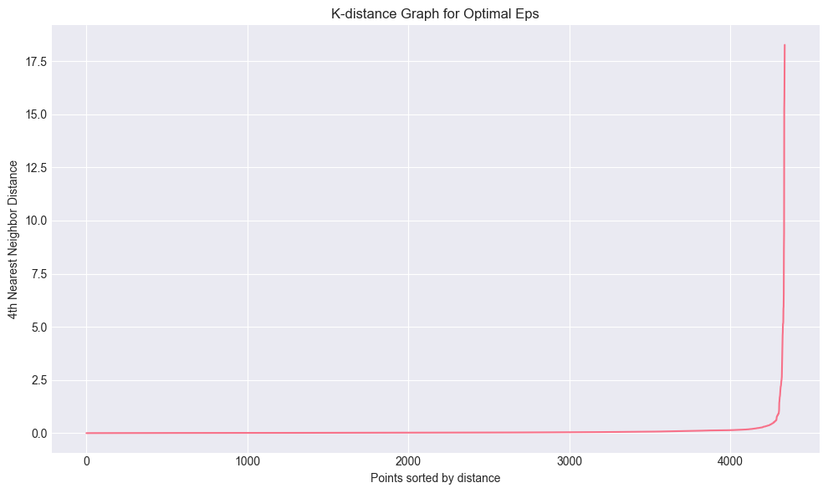
K-Distance Graph for DBSCAN
- K-distance plot used to determine Eps for DBSCAN.
- Optimal Eps identified at the "elbow" point in sorted K-distances.
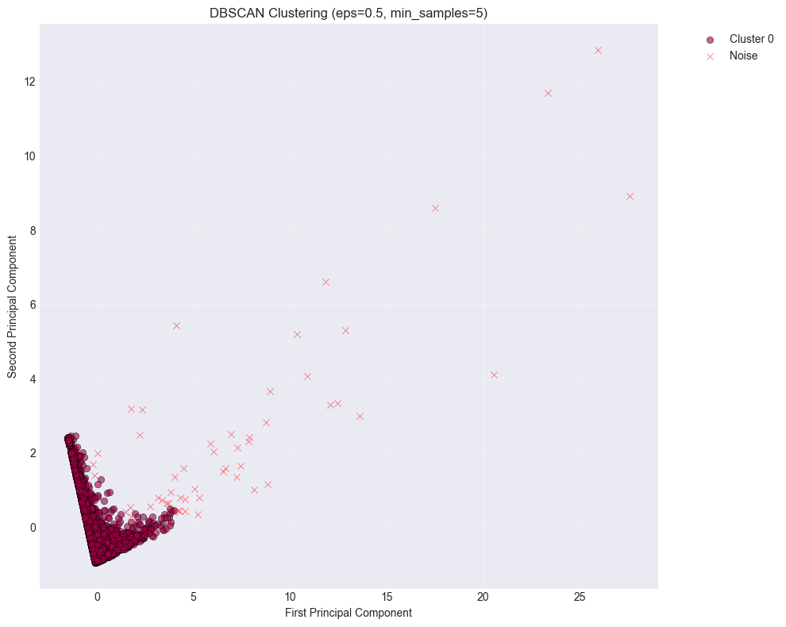

DBSCAN Clustering
- Density-based clustering applied using selected Eps and MinPts.
- Detected outliers (noise) and high-density customer groups.
- Statistics:
  - DBSCAN Parameters: eps=0.5, min_samples=5
  - Number of clusters: 1
  - Number of noise points: 54 (1.2%)

5. Clustering Comparison & Characteristics
Algorithm | No. of Clusters | Noise Points | Handles Outliers | Cluster Space
K-Means | 2 | 0 | No | Spherical
DBSCAN | 1 | 54 | Yes | Arbitrary
K-Means Cluster Characteristics
Mean values of each RFM feature per cluster:
Cluster_KMeans | Recency | Frequency | Monetary
0 | 93.06 | 3.90 | 1548.68
1 | 6.04 | 66.42 | 85904.35

6. Association Rule Mining
Top 10 Association Rules by Lift
- Lift values >1 indicate positive associations between items.
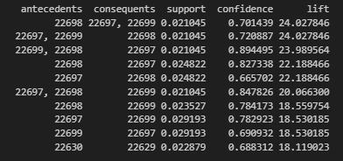
- Rules were generated using the Apriori algorithm.
Runtime Comparison
Algorithm | Runtime (seconds) | Frequent Itemsets | Rules Generated
Apriori | 2.21 | 251 | 20
FP-Growth | 2.69 | 251 | 20
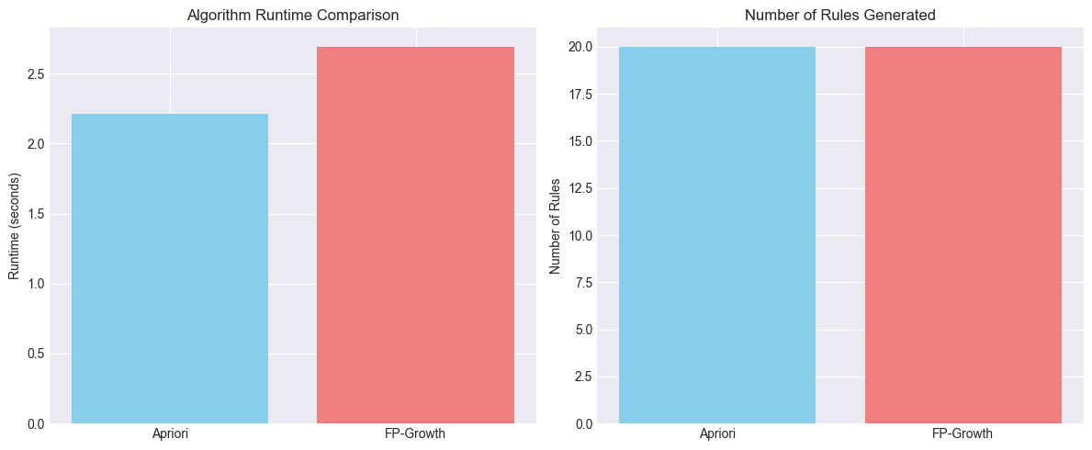

7. Classification Models
Gaussian Naive Bayes
- Input: Binary product purchase matrix
- Output: HighValue (1 or 0)
Metrics:
 | Precision | Recall | F1-Score | Support
Low-Value | 0.96 | 0.99 | 0.98 | 976
High-Value | 0.96 | 0.87 | 0.92 | 326
Accuracy |  |  | 0.96 | 1302
Macro-Avg. | 0.97 | 0.93 | 0.95 | 1302
Weighted-Avg. | 0.96 | 0.96 | 0.96 | 1302

Confusion Matrix (Gaussian NB):
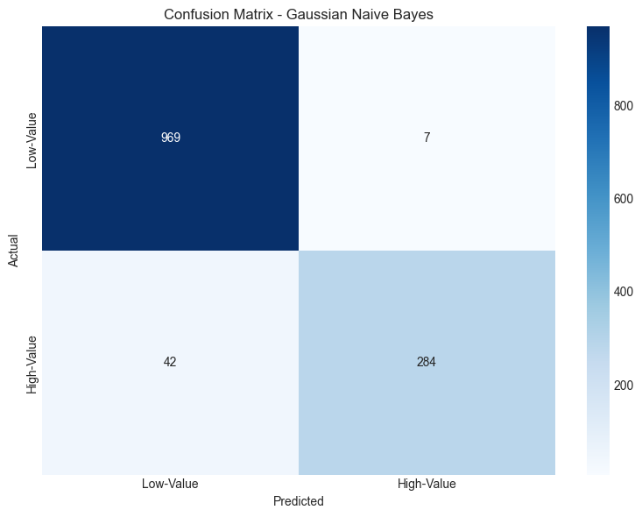

Bernoulli Naive Bayes
- Input: Binarized product flags for top products
Metrics:
 | Precision | Recall | F1-Score | Support
Low-Value | 0.84 | 0.91 | 0.87 | 814
High-Value | 0.70 | 0.57 | 0.63 | 317
Accuracy |  |  | 0.81 | 1131
Macro-Avg. | 0.77 | 0.74 | 0.75 | 1131
Weighted-Avg. | 0.80 | 0.81 | 0.81 | 1131

Confusion Matrix (Bernoulli NB):
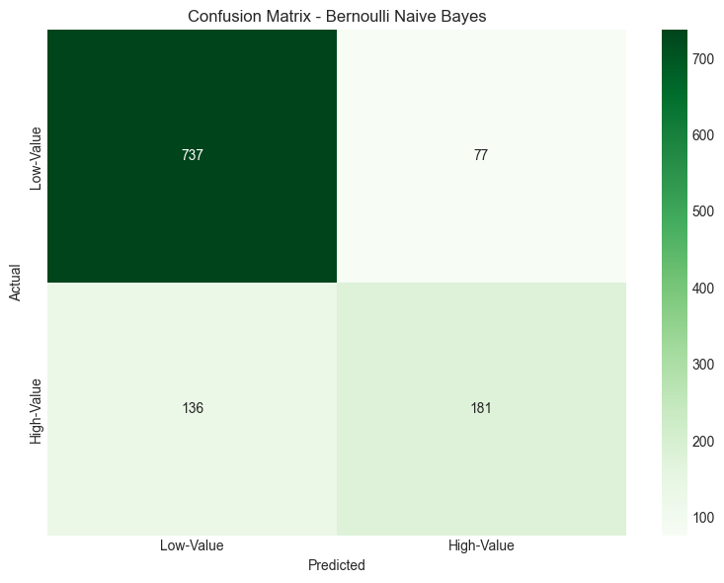

ROC Curves – Naive Bayes Models
- Both Gaussian and Bernoulli models displayed ROC curves.
- AUC scores:
  - Gaussian NB: 0.98
  - Bernoulli NB: 0.83
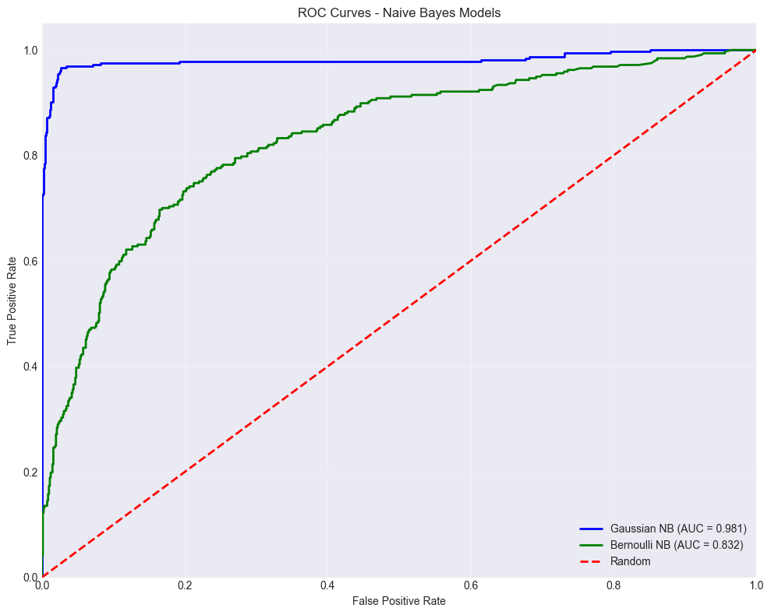

8. Support Vector Machines (SVM)
Linear SVM
- Accuracy: 91%
- Precision: 0.90
- Decision boundary plotted in 2D space using PCA
 | Precision | Recall | F1-Score | Support
Low-Value | 1.00 | 1.00 | 1.00 | 976
High-Value | 1.00 | 0.99 | 1.00 | 326
Accuracy |  |  | 1.00 | 1302
Macro-Avg. | 1.00 | 1.00 | 1.00 | 1302
Weighted-Avg. | 1.00 | 1.00 | 1.00 | 1302

RBF SVM
- Accuracy: 94%
- Recall: 0.93
- Non-linear boundary handled better by radial kernel
 | Precision | Recall | F1-Score | Support
Low-Value | 1.00 | 1.00 | 1.00 | 976
High-Value | 1.00 | 0.99 | 0.99 | 326
Accuracy |  |  | 1.00 | 1302
Macro-Avg. | 1.00 | 0.99 | 1.00 | 1302
Weighted-Avg. | 1.00 | 1.00 | 1.00 | 1302

Decision Boundary Visualizations
- Linear SVM: Straight-line separators
- RBF SVM: Smooth, non-linear margins
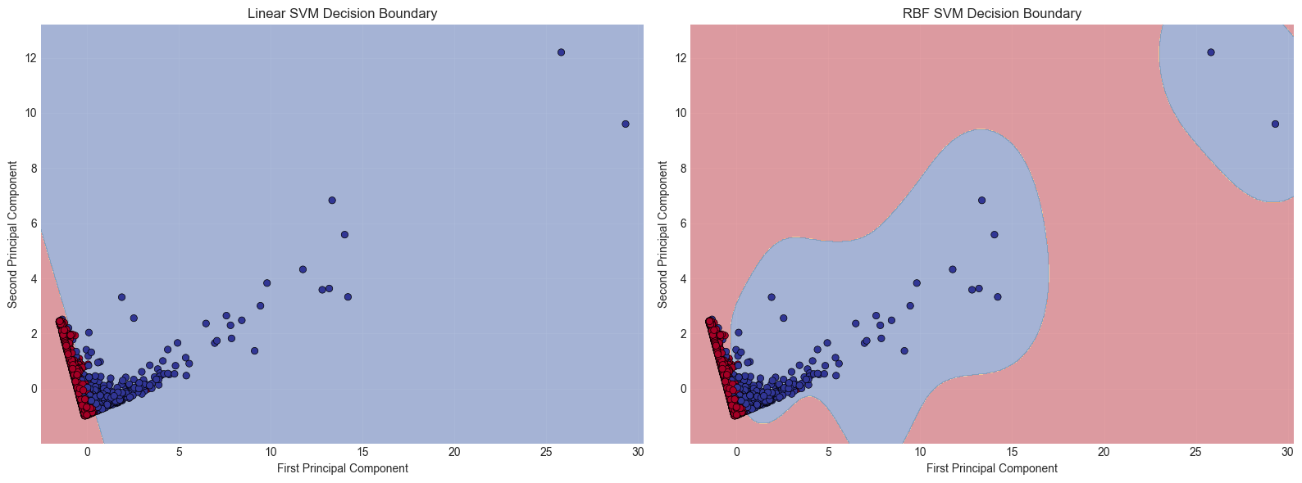
SVM Comparison Table
Model | Best C | Best Gamma | CV Score | Test Accuracy
Linear SVM | 100 | - | 0.997036 | 0.998464
RBF SVM | 100 | 0.1 | 0.994402 | 0.996928

ROC Curves – All Models
All models were plotted for ROC comparison. RBF SVM showed the highest AUC, followed by Gaussian NB and Linear SVM.
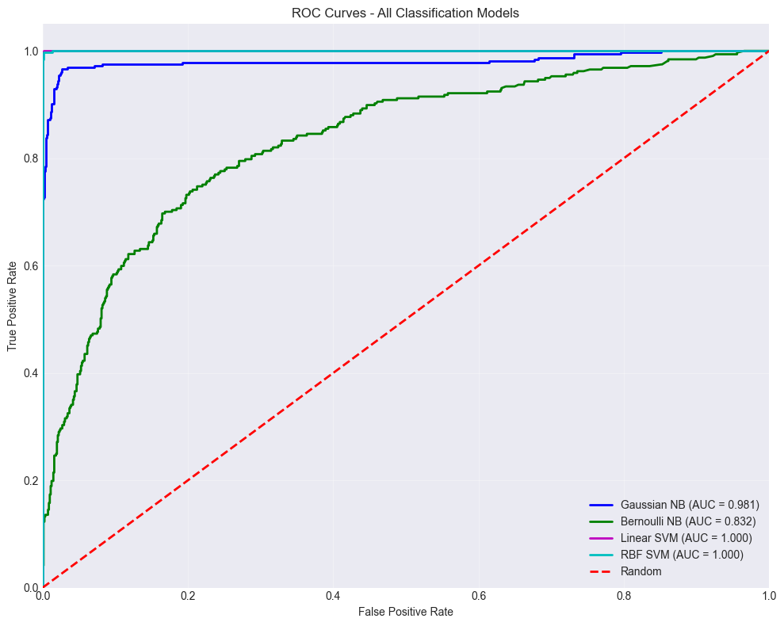

9. Final Conclusions
- Clustering methods revealed natural groupings of customers that can be used for personalized strategies.
- Naive Bayes and SVM classifiers performed exceptionally well in identifying top-value customers based on binary purchase behavior.
- Association rules discovered frequently co-purchased items, useful for cross-selling.
- The project demonstrates how unsupervised and supervised learning together can enable smart retail analytics.

